**Project 2**

**Objectives**

Continue with Project 1 and enhance the relational model and database with advanced SQL queries.

**Project Description**

This project requires you to create a production quality data model, an SQL Server database, and SQL queries to demonstrate the viability of your project and your understanding of the material in this course.

**Submission**: Use this template and submit the following in one PDF file.

Writeup:

1. Add additional features to your project from Project 1. You should aim to have 10 entities in the final ERD. Describe your complete enhanced project in one concise paragraph.

Project Description: Our project has been designed for a sports team. There are no specifics about which sport, but it cannot be an individual sport, like tennis or golf. For data entries, we used data from the NBA. This database could be used by organizations like high-schools, universities and more. The rules for the database are as follows: A Coach has many practices and games. The team has many coaches and players. Every player and coach have a contract. Players must attend games and practices. A person on this team may be an employee or player. If they are an employee, they must be a coach or trainer but not both. If they are a player, they must attend games and practices. A team has many sponsors.

1. Include 5 user stories to describe how your eventual database will be used. (Check out the details of user story [here](https://www.mountaingoatsoftware.com/agile/user-stories#:~:text=User%20stories%20are%20short%2C%20simple,so%20that%20.).)

User Stories:

* As a coach, I want to get an overview of the players' games and see how they can improve or if they need to attend more practices based on the performance.
* As a Sponsor I can advertise my products to a team and grow my company through them.
* As a Player I want to see my opponents for games so that I am well prepared for the upcoming event and can study my opponents' roster.
* As a Trainer I want to see my teams' statics after each game to see what specific training I must incorporate into their routines to improve them.
* As a coach I will be able to keep track of my contract with a team in order to find or stay with my current team.

ERD:

1. Create the ERD for the normalized relational model. If you use EERD for your model, please also submit the implementation model without the extended notations.

SQL: (You cannot use the same answer for multiple questions.)

1. Create 5 (or more) tables that correspond to the entities in your ERD. Choose tables that are in relationship with each other so you can use the tables for the following queries. Show the SQL statements. (Do not forget the primary and foreign keys, and any appropriate constraints.)

*create* *table* Team

(

    Team_ID         *char*(**4**),

    Team_Name       *varchar*(**50**) *not* *null*,

    Team_City       *varchar*(**30**),

    Team_State      *char*(**2**),

    Team_Div        *char*(**2**),

*CONSTRAINT* Teams_PK *primary* *key* (Team_ID)

)

*create* *table* Contracts

(

    Contract_ID     *char*(**4**) *not* *null*,

*Start_Date*      *date* *not* *null*,

    End_Date        *date* *not* *null*,

    Salary          *money*,

    Bonuses         *money*,

*CONSTRAINT* Contracts_PK *primary* *key* (Contract_ID)

)

*create* *table* Coaches

(

    Coach_ID        *char*(**4**),

    Coach_FName     *varchar*(**30**) *not* *null*,

    Coach_LName     *varchar*(**30**) *not* *null*,

    Coach_DOB       *date*,

    Coach_Spec      *varchar*(**50**),

    Contract_ID     *char*(**4**),

    Team_ID         *char*(**4**),

*CONSTRAINT* Coaches_PK *primary* *key* (Coach_ID),

*FOREIGN key* (Contract_ID) *REFERENCES* Contracts(Contract_ID),

*FOREIGN key* (Team_ID) *REFERENCES* Team(Team_ID)

)

*create* *table* Players

(

    Player_ID       *char*(**4**),

    Player_Num     *char*(**2**),

    Player_FName    *varchar*(**30**) *not* *null*,

    Player_LName    *varchar*(**30**) *not* *null*,

    Player_Position *varchar*(**30**),

    Player_Height   *int*,

    Player_Weight   *int*,

    Player_DOB      *date* *not* *null*,

    Contract_ID     *char*(**4**),

    Team_ID         *char*(**4**),

*CONSTRAINT* Players_PK *primary* *key* (Player_ID),

*FOREIGN key* (Contract_ID) *REFERENCES* Contracts(Contract_ID),

*FOREIGN key* (Team_ID) *REFERENCES* Team(Team_ID)

)

*create* *table* Practice

(

    Practice_ID     *char*(**4**),

    PDate           *date* *not* *null*,

    PStart_Time     *time* *not* *null*,

    PEnd_Time       *time*,

    Practice_Type   *varchar*(**40**),

    PLocation       *varchar*(**50**),

*CONSTRAINT* Practice_PK *primary* *key* (Practice_ID)

)

*create* *table* Games

(

    Game_ID     *char*(**4**),

    GDate       *date* *not* *null*,

    GStart_Time *time* *not* *null*,

    GLocation   *char*(**30**),

    Opponent    *char*(**20**),

    Coach_ID    *char*(**4**)

*CONSTRAINT* Game_PK *primary* *key* (Game_ID)

)

*create* *table* Game_Attendence

(

    Player_ID       *char*(**4**),

    Game_ID         *char*(**4**),

*CONSTRAINT* Game_Attendence_PK *primary* *key* (Player_ID, Game_ID),

*FOREIGN KEY* (Player_ID) *REFERENCES* Players(Player_ID),

*foreign key* (Game_ID) *REFERENCES* Games(Game_ID)

)

*create* *table* Practice_Attendence

(

    Player_ID       *char*(**4**),

    Practice_ID     *char*(**4**),

*CONSTRAINT* Practice_Attendence_PK *primary* *key* (Player_ID, Practice_ID),

*FOREIGN KEY* (Player_ID) *REFERENCES* Players(Player_ID),

*FOREIGN KEY* (Practice_ID) *REFERENCES* Practice(Practice_ID)

)

1. Insert some data into each of the tables (at least 10 rows per table). Show the SQL statements, and the content of each table after all the tables are being populated.

*INSERT* *INTO* Team *VALUES*

    ('T001','Golden State Warriors','San Francisco','CA','PA'),

    ('T002','Mavericks','Dallas','TX','SW'),

    ('T003','Bucks','Milwaukee','WI','CE'),

    ('T004','TimberWolves','Minnesota','MI','NW'),

    ('T005','Suns','Phoenix','AZ','PA'),

    ('T006','Jazz','Utah','UT','NW'),

    ('T007','Cavaliers','Cleveland','OH','CE'),

    ('T008','Raptors','Toronto','OT','AT'),

    ('T009','Celtics','Boston','MA','AT'),

    ('T010','Lakers','Los Angeles','CA','PA')

*INSERT* *INTO* Contracts *VALUES*

    ('C001','04-04-2020','04-04-2022',**75000000**,*null*),

    ('C002','02-08-2020','02-08-2022',**70000000**,**12000**),

    ('C003','01-27-2018','01-27-2022',**14000000**,**31000**),

    ('C004','07-15-2020','07-15-2022',**9000000**,*null*),

    ('C005','05-03-2018','05-03-2022',**17000000**,**12000**),

    ('C006','09-19-2021','07-05-2022',**680000000**,**42000**),

    ('C007','05-23-2019','05-03-2022',*null*,*null*),

    ('C008','12-03-2017','05-03-2022',**140000000**,*null*),

    ('C009','09-26-2018','05-03-2022',*null*,**25000**),

    ('C010','03-18-2015','05-03-2022',**140000000**,*null*)

*INSERT* *INTO* Coaches *VALUES*

    ('C200','Steve','Kerr','1965-09-27','Head Coach',*null*,'T001'),

    ('C201','Jason','Kid','1973-03-23','Head Coach','C002','T002'),

    ('C202','Darvin','Ham','1973-02-23','Head Coach','C005','T010'),

    ('C203','Joe','Mazzulla','1988-06-30','Head Coach',*null*,*null*),

    ('C204','John-Blair','Bickerstaff','1979-03-19','Head Coach','C001',*null*),

    ('C205','Galvin','Skett','1968-04-18','Head Coach','C009','T008'),

    ('C206','Zilvia','Thamelt','1977-05-13','Head Coach','C003','T005'),

    ('C207','Joan','Leatherborrow','1987-08-19','Head Coach',*null*,'T003'),

    ('C208','Roz', 'Winsom','1973-03-03','Assistant Coach','C010','T006'),

    ('C209','Stefania','Wipper','1989-08-07','Head Coach','C005',*null*)

*INSERT* *INTO* Players *values*

    ('P001','01','Stephen','Curry','Point Guard',**190**,**185**,'03-14-1988','C001',*null*),

    ('P002','30','Luka','Dončić','Point Guard',**200**,**230**,'02-28-1999','C004','T002'),

    ('P003','01','LeBron','James','Small Forward',**205**,**250**,'12-30-1984','C003','T010'),

    ('P004','72','Jayson','Tatum','Small Forward',**203**,**210**,'03-03-1998',*null*,'T009'),

    ('P005','26','Jarret','Allen','Center',**210**,**243**,'04-21-1998','C009','T001'),

    ('P006','10','Fred','VanVleet','Point Guard',**190**,**240**,'11-26-1999','C003',*null*),

    ('P007','41','Deandre','Ayton','Center',**200**,**230**,'01-03-1998','C005','T005'),

    ('P008','26','Grayson','Allen','Small Forward',**240**,**230**,'09-25-1997',*null*,'T003'),

    ('P009','10','Jaylen','Agbaji','Point Guard',**200**,**218**,'05-06-1998','C008','T007'),

    ('P010','72','Kyle','Anderson','Small Forward',**210**,**235**,'09-04-1999','C010','T004'),

    ('P011','24','Tim','Jaylen','Point Guard',*null*,**185**,'03-14-1988','C001','T001'),

    ('P012',*null*,'Luka','Mark','Point Guard',**202**,**230**,'02-28-1999',*null*,*null*),

    ('P013','32','LeBron','Frank',*null*,**235**,**250**,'12-30-1984','C003','T010'),

    ('P014','73','Charles','Carlos','Small Forward',**203**,**210**,'03-03-1998','C004','T009'),

    ('P015','65','Frank','Austin','Center',**210**,**243**,'04-21-1998',*null*,'T001'),

    ('P016','10','Fred','VanVleet','Point Guard',**190**,**243**,'11-26-1999','C003','T008'),

    ('P017','37','Carlos','Blake','Center',**190**,**200**,'01-03-1998','C005','T005'),

    ('P018','38','Mark','Jaylen','Small Forward',**220**,*null*,'09-25-1997','C001','T003'),

    ('P019','85','Ochai','Adams','Point Guard',**220**,**218**,'05-06-1998',*null*,'T006'),

    ('P020','47','Kyle','Barry','Small Forward',**230**,**235**,'09-04-1999','C010','T004'),

    ('P021','48','Ron','Ayton','Center',**220**,**230**,'01-03-1998','C005','T005'),

    ('P028',*null*,'Aldrich','Baxter','Small Forward',**210**,**234**,'09-25-1997','C001',*null*),

    ('P039','01','Jaylen','Aldrich','Point Guard',**200**,**218**,'05-06-1998','C008','T006'),

    ('P030','38','Barry','Jamel','Small Forward',**250**,**235**,'09-04-1999','C010','T007'),

    ('P031','48','Tim','Carmelo','Point Guard',**190**,**185**,'03-14-1988',*null*,'T001'),

    ('P032','48','Luka','Blake','Point Guard',**202**,**230**,'02-28-1999','C004','T002'),

    ('P033','49','Carmelo','Baxter','Small Forward',**235**,**250**,'12-30-1984','C003','T010'),

    ('P034','52','Charles','Mark','Small Forward',**203**,*null*,'03-03-1998','C004','T009'),

    ('P042','24','Luka','Mark','Point Guard',**202**,**230**,'02-28-1999','C004','T002'),

    ('P053','93','LeBron','Carmelo','Small Forward',**235**,**250**,'12-30-1984','C003','T010'),

    ('P044','74','Malik','Ron','Small Forward',**203**,**210**,'03-03-1998',*null*,'T009'),

    ('P055',*null*,'Frank','Austin','Center',**210**,**243**,'04-21-1998','C009','T001'),

    ('P046','13','Fred','Malik','Point Guard',**190**,**243**,'11-26-1999','C003','T007'),

    ('P047','36','Carmelo','Ron','Center',**190**,**200**,'01-03-1998','C005','T005'),

    ('P048','73','Mark','Malik','Small Forward',**220**,**220**,'09-25-1997','C001','T003'),

    ('P059','10','Ochai','Barry','Point Guard',**220**,**218**,'05-06-1998','C008','T006'),

    ('P060','37','Carmelo','Adams','Small Forward',**230**,**235**,'09-04-1999',*null*,'T004')

*INSERT* *INTO* Practice *VALUES*

    ('PR01','05-23-2022','13:30:00','16:30:00','Conditioning','Chase Center'),

    ('PR02','06-01-2022','08:00:00','10:30:00','Shooting','Madison Square Garden'),

    ('PR03','05-10-2022','16:00:00','18:00:00','Dribbling','Chase Center'),

    ('PR04','06-10-2022','09:30:00','11:30:00',*null*,'Rocket Mortgage FieldHouse'),

    ('PR05','06-01-2022','13:30:00','16:30:00','Shooting','OVO Center'),

    ('PR06','07-24-2022','14:30:00','13:30:00','Conditioning','Madison Square Garden'),

    ('PR07','06-14-2022','18:30:00','19:30:00','Dribbling','Chase Center'),

    ('PR08','02-24-2022','11:30:00','15:30:00','Shooting','Vivint Arena'),

    ('PR09','08-28-2022','14:30:00','23:30:00','Scrimmage','Rocket Mortgage FieldHouse'),

    ('PR10','09-13-2022','15:30:00','18:30:00','Shooting','Vivint Arena')

*INSERT* *INTO* Games *VALUES*

    ('G001','16:00:00','18:00:00','Chase Centre','Nets','C201'),

    ('G002','18:30:00','20:30:00','American Airlines Center','Knicks','C202'),

    ('G003','10:00:00','12:00:00','Crypto.com Arena','Heat', 'C202'),

    ('G004','12:00:00','14:00:00','TD Garden','Nuggets', 'C205'),

    ('G005','14:00:00','16:00:00','Rocket Mortgage FieldHouse','Spurs', 'C205'),

    ('G006','16:00:00','18:00:00','Scotia Bank Arena','Raptors', 'C206'),

    ('G007','18:00:00','20:00:00','Footprint Center','Suns', 'C207'),

    ('G008','20:00:00','22:00:00','Fiserv Forum','Bucks', 'C208'),

    ('G009','12:00:00','16:00:00','Vivint Area','Jazz', 'C209'),

    ('G010','14:00:00','16:00:00','United Centre','Kings', 'C208'),

    ('G011','20:00:00','22:00:00','Target Centre','TimberWolves', 'C200')

*INSERT* *INTO* Game_Attendence *VALUES*

    ('P001','G001'),

    ('P005','G001'),

    ('P011','G001'),

    ('P015','G001'),

    ('P031','G001'),

    ('P002','G003'),

    ('P012','G003'),

    ('P032','G003'),

    ('P042','G003'),

    ('P003','G004'),

    ('P013','G004'),

    ('P033','G004'),

    ('P053','G004')

*INSERT* *INTO* Practice_Attendence *VALUES*

    ('P004','PR03'),

    ('P014','PR03'),

    ('P034','PR03'),

    ('P044','PR03'),

    ('P007','PR06'),

    ('P017','PR06'),

    ('P021','PR06'),

    ('P047','PR06'),

    ('P010','PR07'),

    ('P020','PR07'),

    ('P030','PR07'),

    ('P060','PR07')

1. Come up with one query of your database that requires an inner join of at least two tables. State the purpose of the query, show the SQL statement and the output.

Show how much players who go to a practice make. List the players first and last as play name from the players table and their Salary from contracts only if the player is attending a practice:

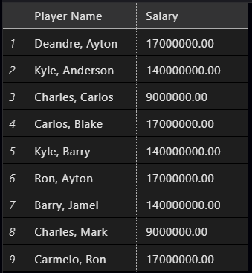

*select* *concat*(**players**.**Player_FName**, ', ', **players**.**Player_LName**) *as*

'Player Name', **Contracts**.**Salary**

*from* Players

*INNER join* Contracts *on* **players**.**Contract_ID** = **Contracts**.**Contract_ID**

*inner join* Practice_Attendence *on* **players**.**Player_ID** = **Practice_Attendence**.**Player_ID**

1. Come up with one query of your database that requires an outer join of at least two tables. State the purpose of the query, show the SQL statement and the output.

Show how much coaches have in bonuses. List all coaches first name and last name from the coaches table and their team name from the team table and bonuses from the contract table where the coach is part of a team

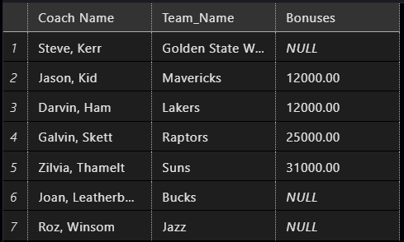

*select* *concat*(**coaches**.**Coach_FName**, ', ', **coaches**.**Coach_LName**) *as*

'Coach Name', **Team**.**Team_Name**, **Contracts**.**Bonuses**

*from* Coaches

*left outer join* Team *on* **Coaches**.**Team_ID** = **Team**.**Team_ID**

*left outer join* Contracts *on* **Coaches**.**Contract_ID** = **Contracts**.**Contract_ID**

*where* **Coaches**.**Team_ID** *is* *not* *null*

1. Come up with one query of your database that requires a subquery. State the purpose of the query, show the SQL statement and the output.

List all players that do not have a game.

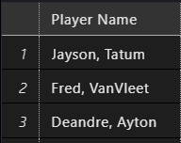

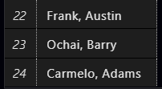

*select* *concat*(Player_FName, ', ', Player_LName) *as* 'Player Name'

*from* Players

*where* Player_ID *not* *in* (

*select* player_ID

*from* Game_Attendence

)

1. Come up with one query of your database that requires an aggregate function. State the purpose of the query, show the SQL statement and the output.

How many people are on each team, list the Team name and count of players:

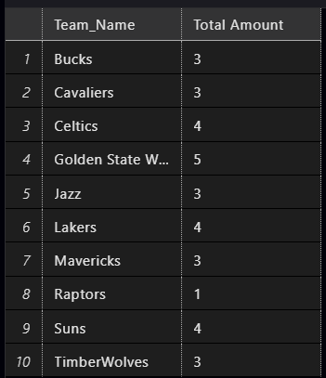

*select* **Team**.**Team_Name**, *count*(Player_ID) *as* 'Total Amount'

*from* Team

*join* Players *on* **Team**.**Team_ID** = **Players**.**Team_ID**

*group by* **Team**.**Team_Name**

1. Come up with one query of your database that requires the OVER clause. State the purpose of the query, show the SQL statement and the output.

Find the amount of bonuses for each team. List the players on each team from the teams table, their team’s name from the team table, and the total amount in bonuses for each team from the contracts table.

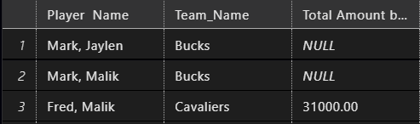

*select*  *concat*(**players**.**player_Fname**, ', ',**Players**.**Player_LName**) *as* 'Player

Name',**Team**.**Team_Name**, *sum*(**Contracts**.**Bonuses**) *over*

(*PARTITION* *by* **Team**.**Team_Name**) *as* 'Total Amount by Team'

*from* Contracts

*join* Players *on* **Contracts**.**Contract_ID** = **players**.**Contract_ID**

*join* Team *on* **players**.**Team_ID** = **Team**.**Team_ID**

1. Come up with a view of your database that limits the user’s access to specific rows and columns. State the purpose of the view, show the SQL statement, an example of how the view is invoked, and the output.

Roster of players on the Warriors team. List the Players name and number on team from San Francisco:

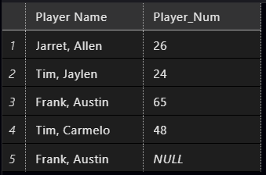

*create* view Warriors_Roster

*as*

*select* *concat*(**players**.**Player_FName**, ', ', **players**.**Player_LName**) *as* 'Player Name', **players**.**Player_Num**

*from* Players

*join* Team *on* **players**.**Team_ID** = **team**.**Team_ID**

*where* **team**.**Team_City** = 'San Francisco'

**Effort Expectation:**

ERD 40%

SQL 40%

Writeup 20%